Kubernetes 07

Task 1: Execute all yaml files shown in video.

- We will create and execute:
- Pod with Toleration (Equal)
- Pod with Toleration (Exists)
- Pod with NodeSelector
- Pod with Soft Node Affinity
- Pod with Hard Node Affinity

- Check Your Cluster
kubectl get nodes
Make sure:
- Nodes are in Ready state.
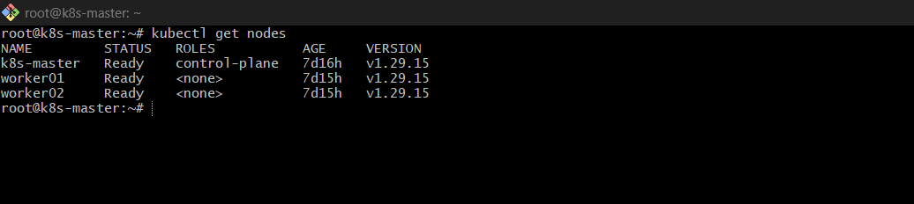
1: Create Toleration Pod (Operator Equal)

1️⃣ Create File
vi toleration-equal.yaml

2️⃣ Paste YAML

apiVersion: v1
kind: Pod
metadata:
name: toleration-equal-pod
spec:
containers:
- name: nginx
image: nginx
tolerations:
- key: "special"
operator: "Equal"
value: "true"
effect: "NoSchedule"

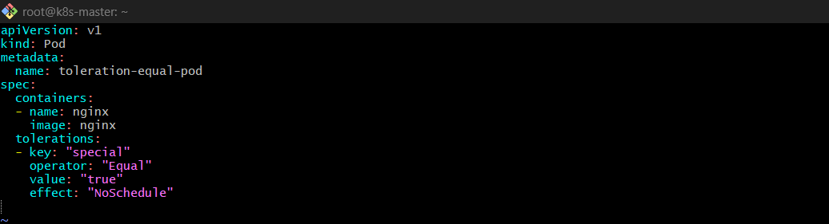
3️⃣ Apply
kubectl apply -f toleration-equal.yaml
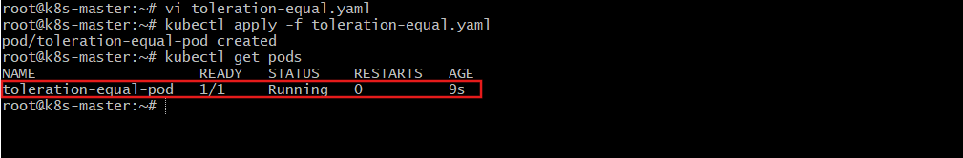
4️⃣ Validate
kubectl get pods
kubectl get pod toleration-equal-pod -o wide
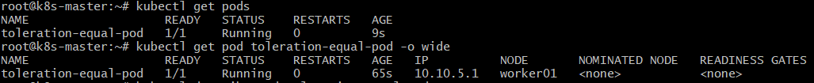
kubectl describe pod toleration-equal-pod
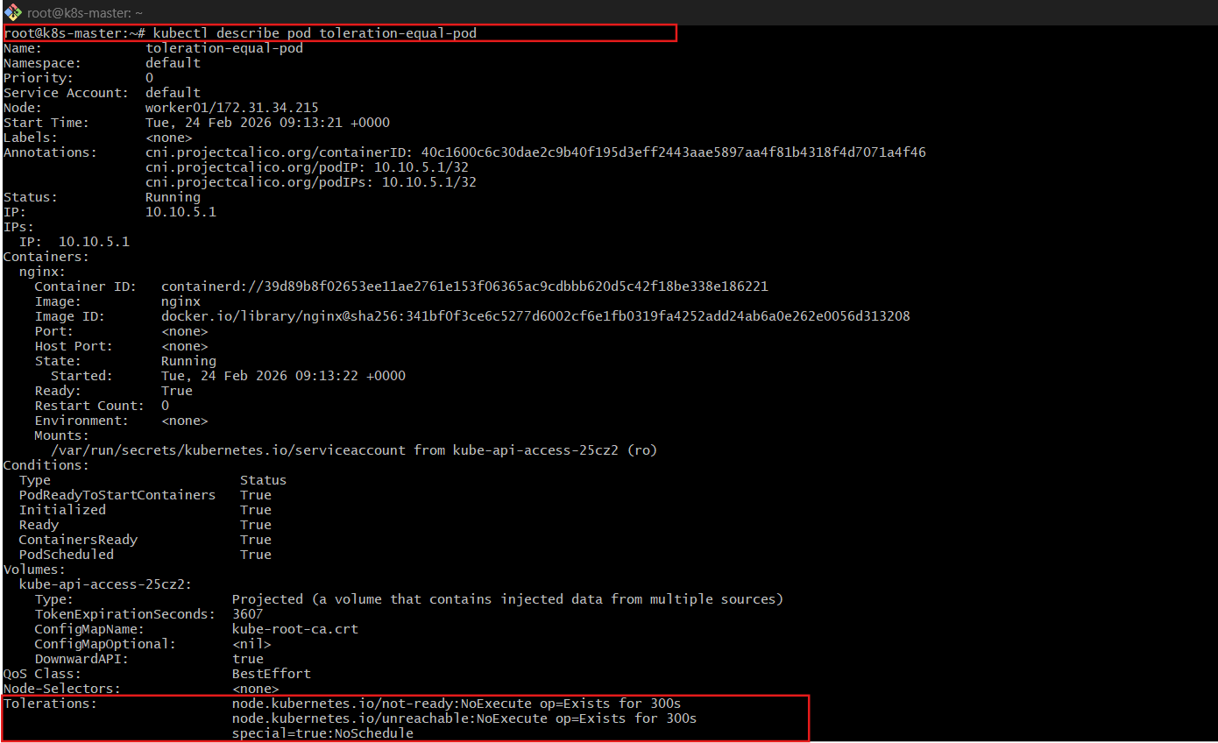
2: Create Toleration Pod (Operator Exists)

1️⃣ Create File
vi toleration-exists.yaml

2️⃣ Paste YAML

apiVersion: v1
kind: Pod
metadata:
name: toleration-exists-pod
spec:
containers:
- name: nginx
image: nginx
tolerations:
- key: "special"
operator: "Exists"
effect: "NoSchedule"
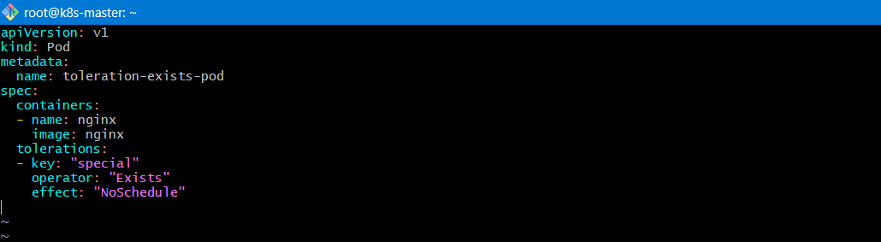

3️⃣ Apply
kubectl apply -f toleration-exists.yaml

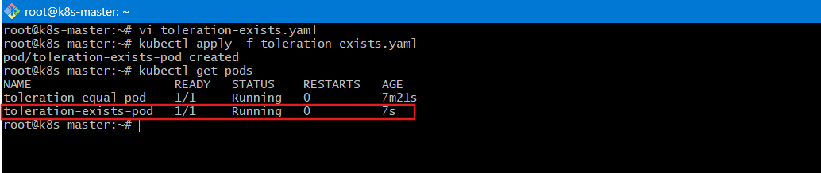
4️⃣ Validate
kubectl get pod toleration-exists-pod -o wide

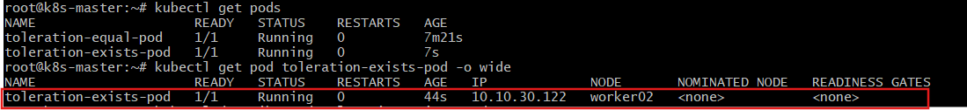
kubectl describe pod toleration-exists-pod
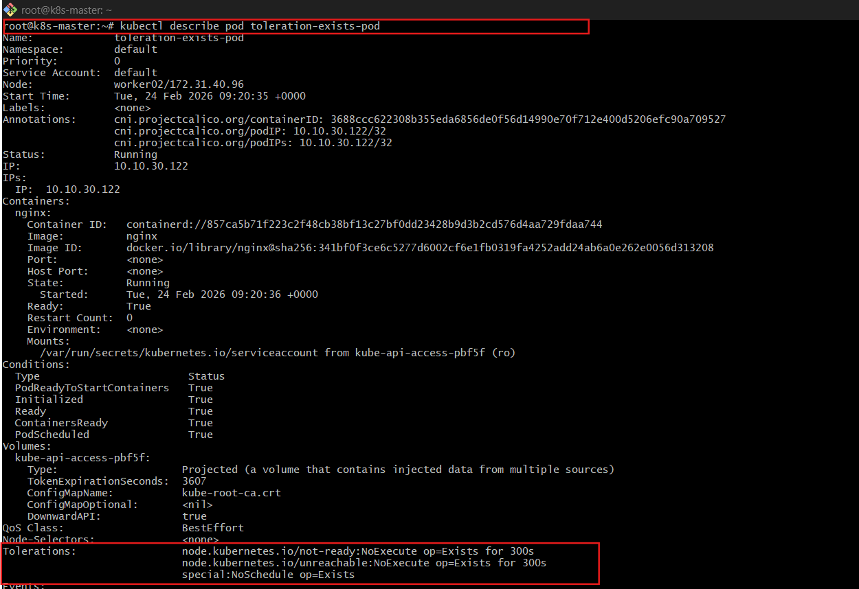

3: NodeSelector Pod

1️⃣ Label a Node

First check node names:
kubectl get nodes
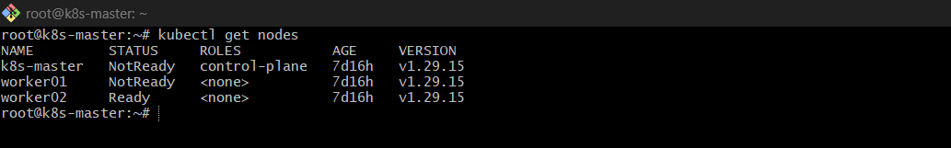
Label one node:
kubectl label nodes <node-name> env=prod

Verify:
kubectl get nodes --show-labels
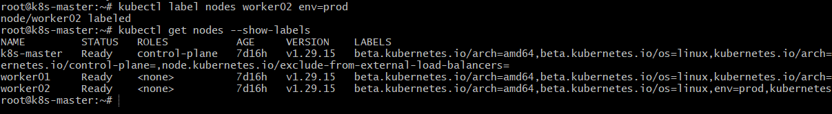
2️⃣ Create YAML

vi nodeselector.yaml
Paste:

apiVersion: v1
kind: Pod
metadata:
name: nodeselector-pod
spec:
nodeSelector:
env: prod
containers:
- name: nginx
image: nginx
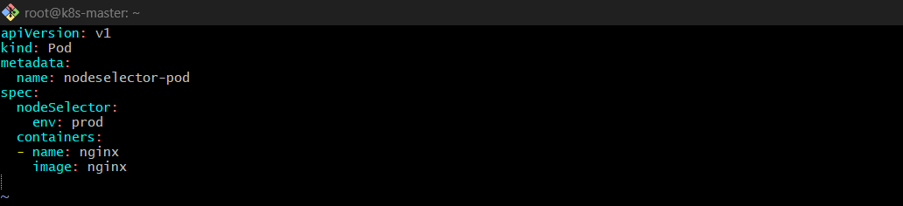
3️⃣ Apply
kubectl apply -f nodeselector.yaml
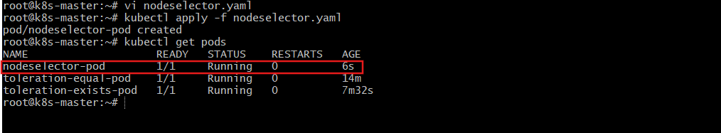
4️⃣ Validate
kubectl get pod nodeselector-pod -o wide
✅ Expected:
- Pod scheduled only on node labeled env=prod
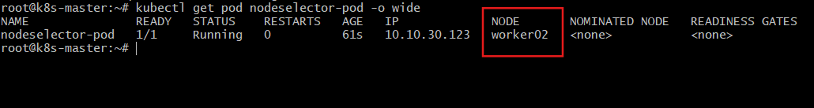
4: Soft Node Affinity (Preferred)

1️⃣ Label Node
kubectl label nodes <node-name> env=test
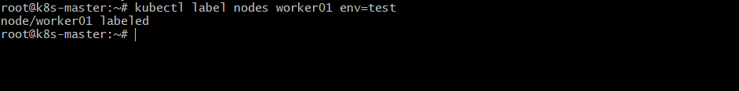
2️⃣ Create YAML
vi soft-affinity.yaml

Paste:
apiVersion: v1
kind: Pod
metadata:
name: soft-affinity-pod
spec:
containers:
- name: nginx
image: nginx
affinity:
nodeAffinity:
preferredDuringSchedulingIgnoredDuringExecution:
- weight: 1
preference:
matchExpressions:
- key: env
operator: In
values:
- test
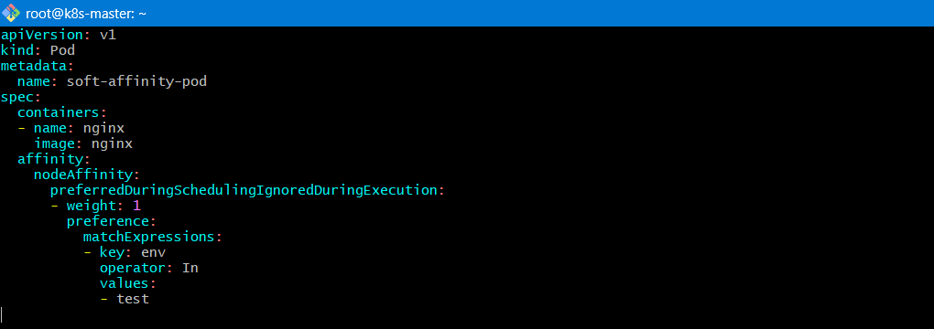
3️⃣ Apply
kubectl apply -f soft-affinity.yaml
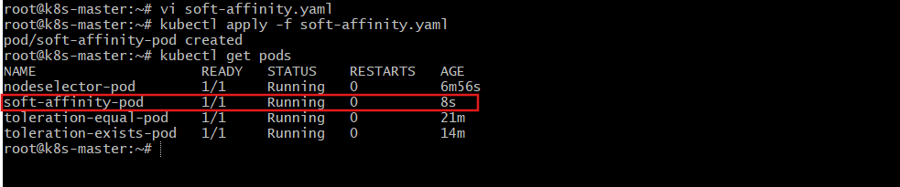
4️⃣ Validate

Expected:
- Scheduler prefers node with env=test
- Pod runs even if label removed

kubectl get pod soft-affinity-pod -o wide
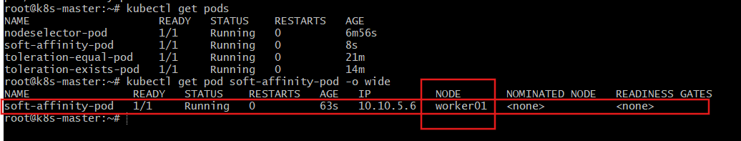

kubectl describe pod soft-affinity-pod

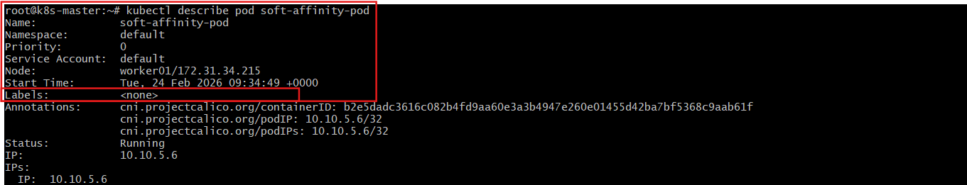

5: Hard Node Affinity (Required)

1️⃣ Create YAML
vi hard-affinity.yaml

Paste:

apiVersion: v1
kind: Pod
metadata:
name: hard-affinity-pod
spec:
containers:
- name: nginx
image: nginx
affinity:
nodeAffinity:
requiredDuringSchedulingIgnoredDuringExecution:
nodeSelectorTerms:
- matchExpressions:
- key: env
operator: In
values:
- prod
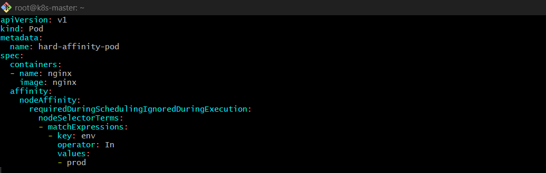
2️⃣ Apply
kubectl apply -f hard-affinity.yaml
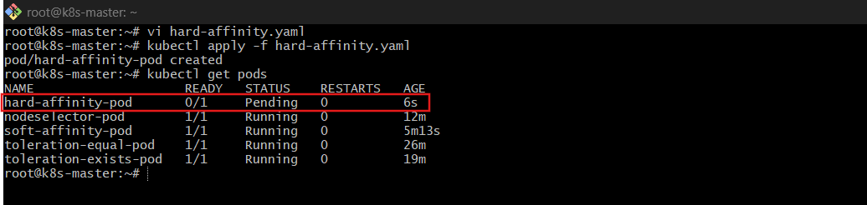
3️⃣ Validate

If node labeled env=prod exists:
kubectl get pod hard-affinity-pod -o wide
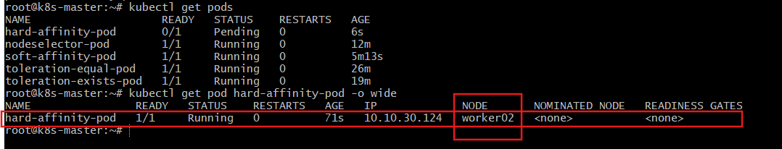
If no matching label:
kubectl describe pod hard-affinity-pod

You will see:
0/2 nodes are available: node(s) didn't match node selector
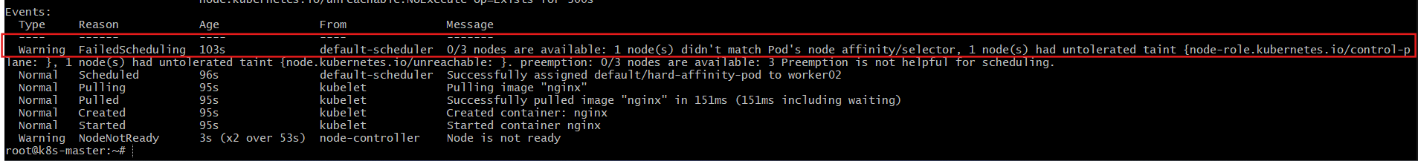

Task 2: Taint a Node and Schedule a Tolerant Pod Taint a node with special=true:NoSchedule. Create a pod with a toleration that matches the taint, allowing it to be scheduled on the tainted node.
Step 1: Check Nodes
kubectl get nodes
Choose a worker node.
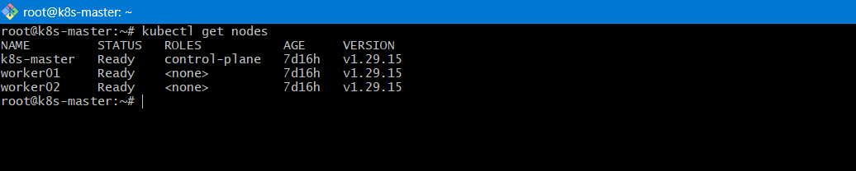
Step 2: Apply Taint
kubectl taint nodes <node-name> special=true:NoSchedule
✅ Explanation:
- special → key
- true → value
- NoSchedule → effect
- This blocks new pods from scheduling unless they tolerate it.
Verify:
kubectl describe node <node-name> | grep Taint
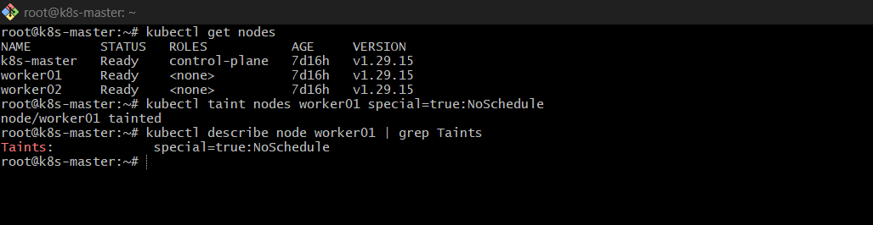
Step 3: Create Pod with Toleration
vi tolerant-pod.yaml
apiVersion: v1
kind: Pod
metadata:
name: tolerant-pod
spec:
containers:
- name: nginx
image: nginx
tolerations:
- key: "special"
operator: "Equal"
value: "true"
effect: "NoSchedule"
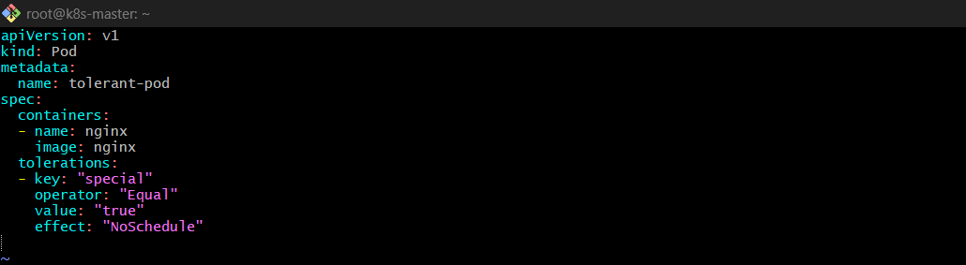
Apply:
kubectl apply -f tolerant-pod.yaml
Check scheduling:
kubectl get pod tolerant-pod -o wide
Explanation:
Scheduler sees:
- Node has taint
- Pod has matching toleration
→ Pod allowed to schedule.
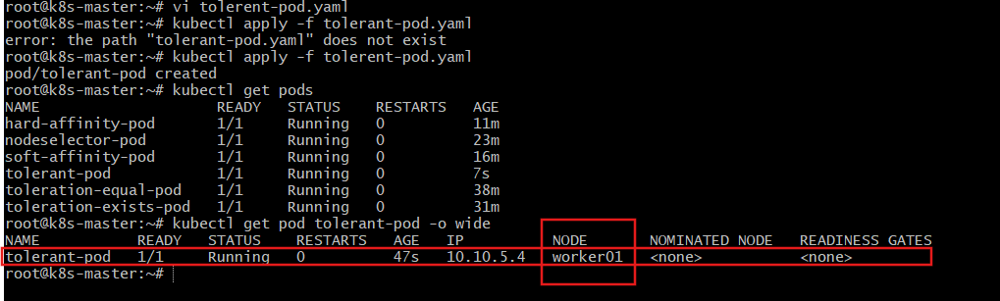
Task 3: Use NodeSelector to Schedule a Pod on a Specific Node Label a node with env=dev. Create a pod with a nodeSelector that schedules it only on the node labeled env=dev.
Step 1: Label Node
kubectl label nodes <node-name> env=dev
Verify:
kubectl get nodes --show-labels
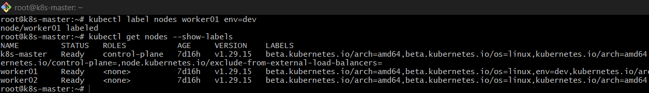

Step 2: Create Pod with NodeSelector
vi nodeselector.yaml
apiVersion: v1
kind: Pod
metadata:
name: nodeselector-pod
spec:
nodeSelector:
env: dev
containers:
- name: nginx
image: nginx
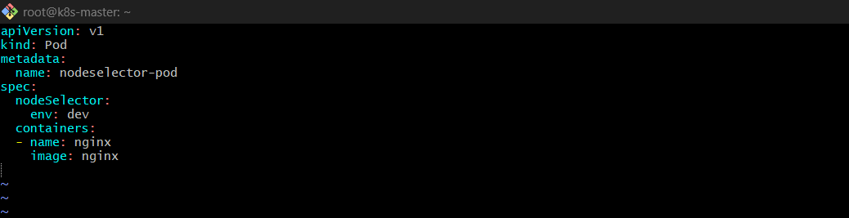
Apply:
kubectl apply -f nodeselector.yaml
Check:
kubectl get pod nodeselector-pod -o wide
✅ Explanation:
NodeSelector is:
- Simple key-value matching
- Hard requirement
If no node has env=dev, pod stays Pending.
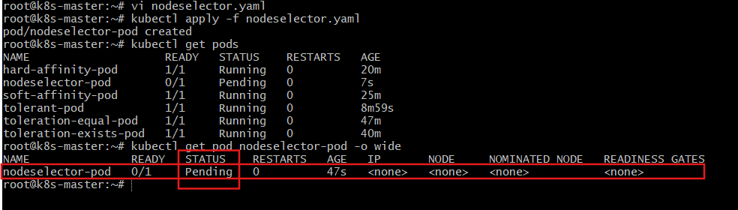
Task 4: Use Node Affinity with Soft Scheduling Label a node with env=test. Create a pod with PreferredDuringSchedulingIgnoredDuringExecution node affinity, preferring to schedule it on a node labeled env=test. Remove the label and verify the pod continues to run.
Step 1: Label Node
kubectl label nodes <node-name> env=test
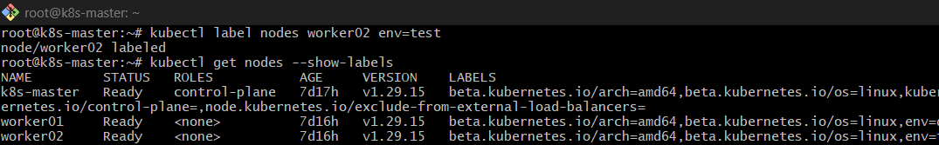
Step 2: Create Pod with Preferred Affinity
vi soft-affinity.yaml
apiVersion: v1
kind: Pod
metadata:
name: soft-affinity-pod
spec:
affinity:
nodeAffinity:
preferredDuringSchedulingIgnoredDuringExecution:
- weight: 1
preference:
matchExpressions:
- key: env
operator: In
values:
- test
containers:
- name: nginx
image: nginx
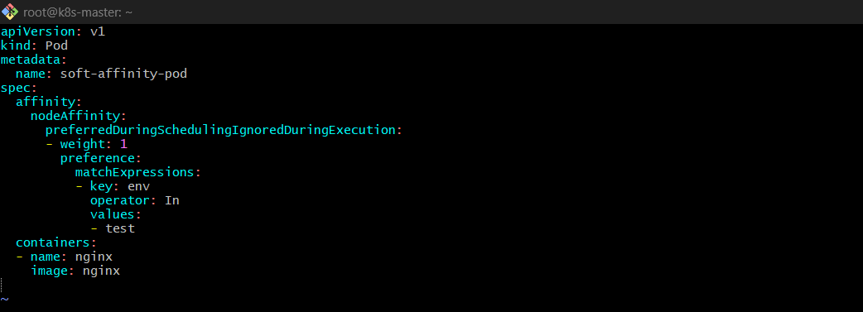
Apply:
kubectl apply -f soft-affinity.yaml
kubectl get pod soft-affinity-pod -o wide
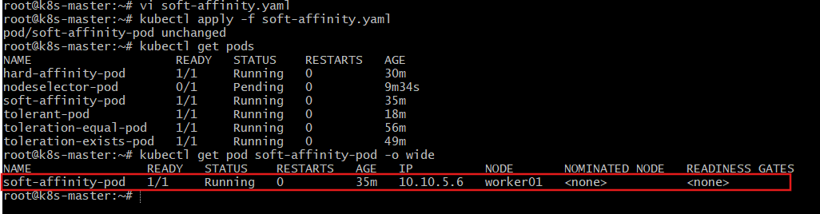
Step 3: Remove Label
kubectl label nodes <node-name> env-
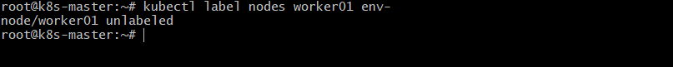
✅ Pod continues running because:
- IgnoredDuringExecution means label removal does NOT evict the pod.
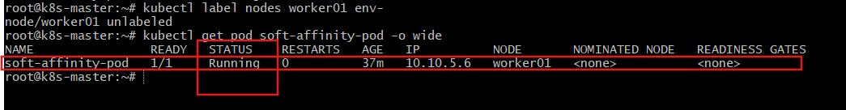
Task 5: Implement Node Affinity with Hard Scheduling Create a pod with RequiredDuringSchedulingIgnoredDuringExecution node affinity, ensuring it will only be scheduled on a node labeled env=prod. Verify the pod cannot be scheduled if no node has the env=prod label.
Step 1: Create Pod with Required Affinity
vi hard-affinity.yaml
apiVersion: v1
kind: Pod
metadata:
name: hard-affinity-pod
spec:
affinity:
nodeAffinity:
requiredDuringSchedulingIgnoredDuringExecution:
nodeSelectorTerms:
- matchExpressions:
- key: env
operator: In
values:
- prod
containers:
- name: nginx
image: nginx
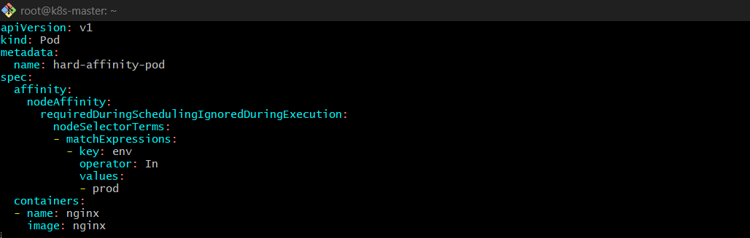
Apply:
kubectl apply -f hard-affinity.yaml
kubectl get pod hard-affinity-pod
Step 2: Verify Behavior
If NO node has env=prod:
kubectl get pods
kubectl describe pod hard-affinity-pod
You will see:
0/3 nodes are available: node(s) didn't match node selector
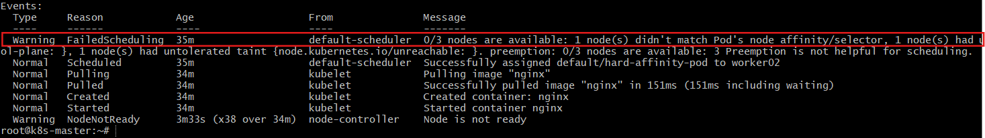
Now label a node:
kubectl label nodes worker01 env=prod
Pod will schedule immediately.
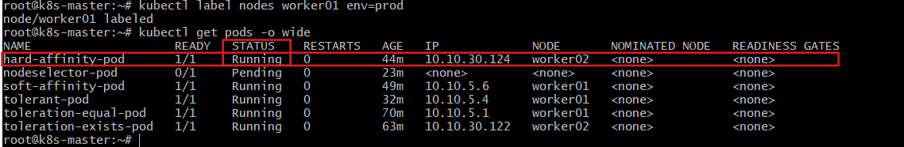

Task 6: Taint a Node and Use NoExecute with Toleration Seconds Taint a node with special=true:NoExecute. Create a pod with a tolerationSeconds field (e.g., 60 seconds) and observe it gets evicted after 60 seconds on the tainted node.
Step 1: Taint Node
kubectl taint nodes <node-name> special=true:NoExecute
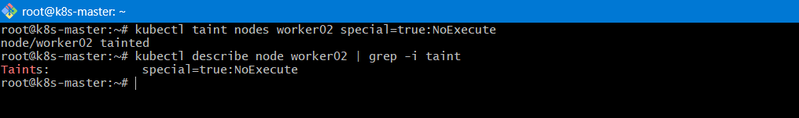
Step 2: Create Pod with tolerationSeconds
vi noexecute.yaml
apiVersion: v1
kind: Pod
metadata:
name: noexecute-pod
spec:
tolerations:
- key: "special"
operator: "Equal"
value: "true"
effect: "NoExecute"
tolerationSeconds: 60
containers:
- name: nginx
image: nginx
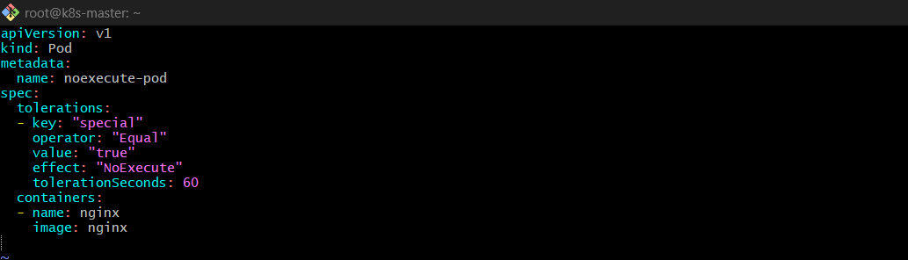
Apply:
kubectl apply -f noexecute.yaml

Step 3: Observe Eviction
Check pod:
kubectl get pod noexecute-pod -w
After 60 seconds, the pod will be automatically evicted.
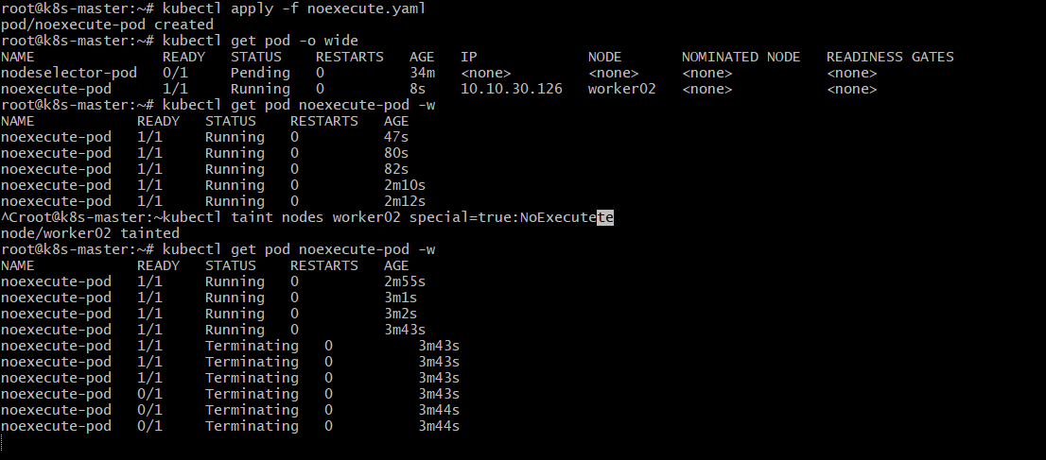
Check events:
kubectl describe pod noexecute-pod
You will see eviction message due to taint.

